**Software Requirement Specification**

**(SRS)**

**SWASTH BHARAT**

**1. Introduction**

* **1.1 Purpose**
  + The purpose of this document is to describe the software requirements for the "Swasth Bharat" mobile application, which allows patients to book appointments with doctors. The application is designed to enhance the accessibility of healthcare services by providing a convenient platform for scheduling appointments and managing patient-doctor interactions.
* **1.2 Scope**
  + The "Swasth Bharat" app will be developed using Flutter for the front-end, Node.js with Express.js for the back-end, and MongoDB for the database. It will provide features such as doctor availability lookup, location-based doctor search, appointment booking, in-app notifications, payment gateway integration, blockchain for securing patient records, and machine learning-based recommendations. Additionally, the app will include doctor registration and login, patient reviews and ratings for doctors, and Google Maps integration for navigation to the doctor's clinic.
* **1.3 Intended Use**
  + The "Swasth Bharat" app is intended to be used by patients seeking to book medical appointments with doctors and by doctors who want to manage their consultation schedules. The app aims to simplify the process of finding doctors, scheduling appointments, and managing patient records securely. It also provides tools for patients to rate and review doctors, ensuring an informed decision-making process.
* **1.4 Intended Audience**
  + **Patients:** Individuals who require medical consultations and want to easily find and book appointments with doctors.
  + **Doctors:** Medical professionals who wish to offer their consultation services through a digital platform, manage their availability, and receive patient feedback.
  + **Healthcare Administrators:** Individuals responsible for managing the overall operation of the app, including user management, doctor availability, and monitoring of ratings and reviews.
  + **Developers and Engineers:** The team responsible for the development, maintenance, and enhancement of the application.

**2. Overall Description**

* **2.1 Product Perspective**
  + The "Swasth Bharat" app will be a new, independent application designed to meet the needs of patients and doctors seeking a streamlined, digital approach to healthcare services. The app will integrate multiple technologies to ensure secure, efficient, and user-friendly service delivery.
* **2.2 Product Functions**
  + **User Registration and Login:** Both patients and doctors can register and log in to the app.
  + **Doctor Availability:** Patients can search for doctors based on specialty and check their availability.
  + **Location-Based Search:** Patients can find doctors near their location, sorted by the shortest distance.
  + **Appointment Booking:** Patients can book appointments with doctors and receive confirmation notifications.
  + **Conflict Resolution:** The system will prevent double booking or conflicting consultation schedules.
  + **Notifications:** Patients receive reminders one hour before the appointment, with a Google Maps link to driving directions to the doctor’s clinic.
  + **Reviews and Ratings:** Patients can review and rate doctors based on their experiences.
  + **Payment Gateway:** Patients can pay for consultations using Apple Pay and Google Pay.
  + **Blockchain Security:** Patient reports will be securely stored using blockchain technology.
  + **In-App Recommendations:** Personalized health recommendations will be provided using Firebase ML Kit.
* **2.3 User Characteristics**
  + **Patients:** Individuals seeking medical consultations.
  + **Doctors:** Medical professionals offering consultation services.
  + **Admin:** Manages user accounts, doctor availability, reviews, and system operations.
* **2.4 Constraints**
  + The app must be available on both Android and iOS platforms.
  + It should comply with relevant healthcare data protection regulations.
  + Internet connectivity is required for all functionalities.
* **2.5 Assumptions and Dependencies**
  + Patients and doctors have access to smartphones.
  + The app relies on third-party services like payment gateways and Google Maps API.

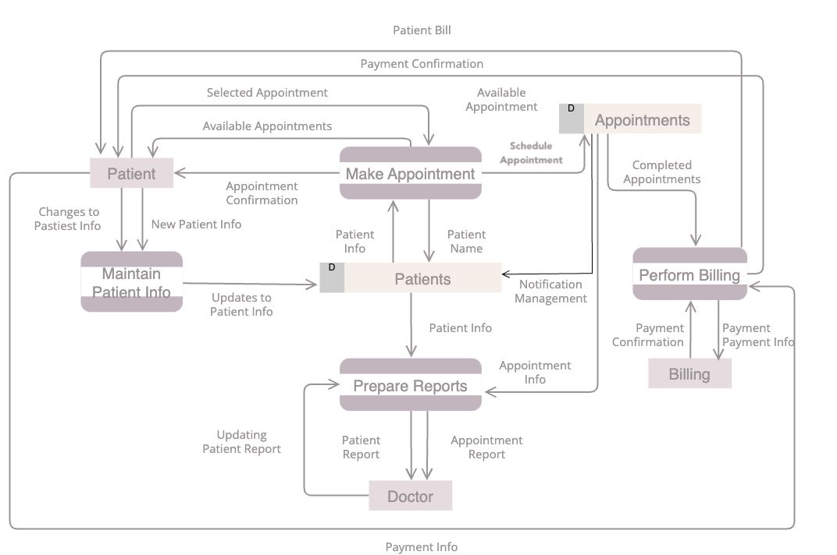

3.1 DFD DIAGRAM

**3. Specific Requirements**

* **3.1 Functional Requirements**
  + **3.1.1 User Registration and Login**
    - The system shall allow patients and doctors to register with their name, email, phone number, and password.
    - The system shall provide authentication for login using email/phone and password.
  + **3.1.2 Doctor Availability Search**
    - The system shall allow patients to search for doctors by specialty.
    - The system shall display a list of doctors with available time slots.
  + **3.1.3 Location-Based Doctor Search**
    - The system shall allow patients to search for doctors near their location.
    - The system shall sort the doctors by proximity to the patient's current location.
  + **3.1.4 Appointment Booking**
    - The system shall allow patients to book appointments with selected doctors.
    - The system shall send a confirmation notification after a successful booking.
    - The system shall prevent double bookings or conflicting appointments.
  + **3.1.5 Notifications**
    - The system shall send a reminder notification to the patient one hour before the appointment.
    - The reminder shall include a link to Google Maps with driving directions to the doctor’s clinic.
  + **3.1.6 Reviews and Ratings**
    - The system shall allow patients to review and rate doctors after their appointment.
    - The system shall display average ratings and reviews on the doctor’s profile.
  + **3.1.7 Payment Gateway Integration**
    - The system shall integrate with Apple Pay and Google Pay for processing payments.
    - The system shall confirm payment success or failure within the app.
  + **3.1.8 Blockchain Security**
    - The system shall use blockchain technology to securely store patient medical reports.
    - The system shall provide patients with access to their reports at any time.
  + **3.1.9 In-App Recommendations**
    - The system shall use Firebase ML Kit to provide personalized health recommendations to patients.
* **3.2 Non-Functional Requirements**
  + **3.2.1 Performance**
    - The system shall load doctor availability and location-based search results within 5 seconds.
  + **3.2.2 Security**
    - The system shall use secure protocols (HTTPS) for data transmission.
    - All sensitive data, such as payment information, shall be encrypted.
  + **3.2.3 Usability**
    - The app shall have an intuitive user interface that follows platform-specific guidelines for Android and iOS.
  + **3.2.4 Compatibility**
    - The app shall be compatible with the latest versions of Android and iOS.
  + **3.2.5 Scalability**
    - The system shall be scalable to handle increased numbers of users without performance degradation.

**4. System Architecture**

* **4.1 Overview**
  + The app will follow a client-server architecture. The front-end (Flutter) will interact with the back-end (Node.js/Express.js) via RESTful APIs. MongoDB will be used for data storage. Blockchain technology will be integrated for securing patient reports. Payment gateways and Firebase ML Kit will be integrated via their respective APIs. Google Maps API will be used for providing navigation links in notifications.

**5. Database Design**

* **5.1 User Table**
  + Fields: User ID, Name, Email, Phone Number, Password (hashed), Role (Patient/Doctor/Admin)
* **5.2 Doctor Table**
  + Fields: Doctor ID, Name, Specialty, Location (Latitude, Longitude), Availability (Time Slots), Rating
* **5.3 Appointment Table**
  + Fields: Appointment ID, Patient ID, Doctor ID, Date, Time Slot, Status (Confirmed/Cancelled)
* **5.4 Payment Table**
  + Fields: Payment ID, Appointment ID, Patient ID, Amount, Payment Method (Apple Pay/Google Pay), Status
* **5.5 Report Table**
  + Fields: Report ID, Patient ID, Doctor ID, Date, File (Encrypted URL), Blockchain Hash
* **5.6 Reviews Table**
  + Fields: Review ID, Patient ID, Doctor ID, Rating, Comment, Date

**6. External Interface Requirements**

* **6.1 User Interfaces**
  + The app shall have a user-friendly interface, with screens for registration, login, doctor search, appointment booking, reviews, and payment.
* **6.2 APIs**
  + The app shall use RESTful APIs for communication between the front-end and back-end.
  + Third-party APIs like Google Maps for location services and payment gateway APIs for processing payments shall be integrated.
* **6.3 Hardware Interfaces**
  + The app shall interface with mobile device hardware for GPS location services and payment processing.

**7. Appendices**

* **7.1 Glossary**
  + **Blockchain:** A decentralized ledger technology used for securely storing data.
  + **Firebase ML Kit:** A mobile machine learning SDK provided by Google for creating personalized experiences.
  + **Google Maps API:** An API that enables the integration of Google Maps services into mobile and web applications for providing location-based information.